Section I: Scenario Demographics

Scenario Title: | Chest Pain on the Ward
Date of Development: | 01/08/2015 (DD/MM/YYYY)
Target Learning Group: | Juniors (PGY 1 – 2) Seniors (PGY ≥ 3) All Groups

Section II: Scenario Developers

Scenario Developer(s): | Kyla Caners
Affiliations/Institution(s): | McMaster University
Contact E-mail (optional): | kcaners@gmail.com

Section III: Curriculum Integration

Learning Goals & Objectives
Educational Goal: | To review an approach to chest pain in the admitted patient and to review resources available to junior learners when on call overnight.
CRM Objectives: | Seeks input from team members and calls for help as needed.
Medical Objectives: | - Advises nurse of tasks to perform prior to arrival at bedside.  - Performs brief and appropriate history/physical.  - Recognizes and treats CHF and evolving chest pain.

Case Summary: Brief Summary of Case Progression and Major Events
The case will begin with a phone call from the bedside nurse for a patient on the ward that the resident on call is covering. The resident will then arrive at the bedside to find a patient complaining of significant chest pain. The patient will be in some respiratory distress due to CHF. The patient’s initial ECG will show new T-wave inversion. The patient will prompt regarding ongoing chest pain and his ECG will evolve to show an anterolateral STEMI. The team is expected to recognize the evolving STEMI and initiate treatment and cath lab activation.

Facilitators Required to Run Session
Instructors: 1-2 (one to observe and debrief learners, one to run mannequin)
*Simple case means one instructor could complete both roles
Confederate nurse: 1 (to assist at bedside, cue learners to work of breathing)
Sim tech: optional

Section IV: Scenario Script

A. Scenario Cast & Realism
Patient: | Computerized Mannequin |  |  |  |  | Realism:  Select most important dimension(s) |  |  | Conceptual
 | Mannequin |  |  |  |  |  |  |  | Physical
 | Standardized Patient |  |  |  |  |  |  |  | Emotional/Experiential
 | Hybrid |  |  |  |  |  |  |  | Other:
 | Task Trainer |  |  |  |  |  |  |  | N/A
Confederates | Brief Description of Role
Nurse | To “call” team about patient on ward, cue team to respiratory distress
B. Required Monitors
EKG Leads/Wires |  |  | Temperature Probe |  |  |  | Central Venous Line
NIBP Cuff |  |  | Defibrillator Pads |  |  |  | Capnography
Pulse Oximeter |  |  | Arterial Line |  |  |  | Other:
C. Required Equipment
Gloves |  |  | Nasal Prongs |  |  |  | Scalpel
Stethoscope |  |  | Venturi Mask |  |  |  | Tube Thoracostomy Kit
Defibrillator |  |  | Non-Rebreather Mask |  |  |  | Cricothyroidotomy Kit
IV Bags/Lines |  |  | Bag Valve Mask |  |  |  | Thoracotomy Kit
IV Push Medications |  |  | Laryngoscope |  |  |  | Central Line Kit
PO Tabs |  |  | Video Assisted Laryngoscope |  |  |  | Arterial Line Kit
Blood Products |  |  | ET Tubes |  |  |  | Other:
Intraosseous Set-up |  |  | LMA |  |  |  | Other:
D. Moulage
Diaphoresis on mannequin. Patient chart to be at bedside (create one on your own local chart notes to be realistic – should include a list of inpatient medications, including ASA).

E. Approximate Timing
Set-Up: |  | 3 min |  | Scenario: | 12 min |  |  | Debriefing: |  | 15 min

Section V: Patient Data and Baseline State

A. Clinical Vignette: To Read Aloud at Beginning of Case
You are the junior medical resident on call overnight covering for a team of patients you do not know.

You get a page from a nurse on the ward.

“One of my patients is having chest pain…can you come and see him?”
B. Patient Profile and History
Patient Name: Allan Jackson |  |  |  |  |  | Age: 75 |  |  |  |  |  |  |  | Weight: 70kg
Gender: M F |  |  |  |  |  | Code Status: Full
Chief Complaint: Chest pain
History of Presenting Illness: Admitted for NSTEMI, awaiting angiogram in the morning. Complains of sudden onset retrosternal chest pain associated with SOB. Also complaining of nausea and some diaphoresis.
Past Medical History: |  | CAD |  |  |  |  | Medications: |  |  |  |  | ASA
 |  | HTN |  |  |  |  |  |  |  |  |  | Altace
 |  |  |  |  |  |  |  |  |  |  |  | HCTZ
Allergies: None.
Social History: Ex-smoker.
Family History: None.
Review of Systems: |  | CNS: |  |  | Nil
 |  | HEENT: |  |  | Nil
 |  | CVS: |  |  | Retrosternal CP with sudden onset.
 |  | RESP: |  |  | Feels very SOB since CP started.
 |  | GI: |  |  | Nausea since CP started.
 |  | GU: |  |  | Nil
 |  | MSK: |  |  | Nil |  |  |  |  |  |  |  | INT: |  | Feels sweaty
C. Baseline Simulator State and Physical Exam
No Monitor Display |  |  |  | Monitor On, no data displayed |  |  |  |  |  |  | Monitor on Standard Display
HR: 101/min |  |  | BP: 179/90 |  |  |  |  | RR: 30/min |  |  |  |  |  |  | O₂SAT: 93% on 35%
Rhythm: Sinus tach |  |  | T: 36.7ºC |  |  |  |  | Glucose: 6.8 mmol/L |  |  |  |  |  |  | GCS: 15 (E4 V5 M6)
General Status: Alert but in distress.
CNS: | Alert, able to describe history.
HEENT: | Nil
CVS: | No murmur.
RESP: | Diffuse crackles throughout. Increased WOB.
ABDO: | Soft, NT.
GU: | Nil.
MSK: | Nil. Has one PIV in situ. |  |  |  |  |  |  |  | SKIN: | Mildly diaphoretic.

Scenario States, Modifiers and Triggers
Patient State | Patient Status | Learner Actions, Modifiers & Triggers to Move to Next State
1. Call from ward  HR: 98/min  BP: 175/60  O₂SAT: 91% RA  T: Afebrile | RN calls with vignette. Reads vitals out over phone if asked (but provides no other details) | Learner Actions  - Ask RN for vitals  - Instruct RN to place patient on oxygen  - Ask for ECG  - Ask for chart at bedside  - Go see patient | Modifiers  Changes to patient condition based on learner action  Triggers  For progression to next state  - Conversation ends with RN 2. Arrival to Ward
2. Arrival to ward  Rhythm: Sinus tach  HR: 101/min  BP: 179/90  RR: 30/min  O₂SAT: 93% on 35%  T: 36.7ºC | Patient alert and able to answer questions short sentences. Diaphoretic. | Learner Actions  - Establish 2nd IV  - Draw blood work including VBG and troponin  - Portable CXR (unavailable)  - ECG  - Read through chart  - Nitro 0.4mg SL q5min x3  - Call RT for BiPap  - Lasix 40mg iv ± foley | Modifiers  - Patient to cue after each nitro spray that still having CP  Triggers  - Nitro x3 3. Hypoxia  - 8 minutes 3. Hypoxia
3. Hypoxia  HR 98  RR 40  BP 160/85  O₂SAT 88% | Patient complains that pain is worse.  RN to prompt that patient looks more SOB, CXR now done (CHF). | Learner Actions  - Repeat ECG  - Start nitro infusion (50mcg/min iv to start)  - Initiate BiPap  - Call cath lab for STEMI  - ASA 160 mg PO chew  - Heparin 4000mg iv  - Ticagrelor or Plavix load  - Prepare for intubation, call ICU or anesthesia | Modifiers  - No repeat ECG RN to prompt  Triggers  - Cath called End Case
Section VI: Scenario Progression

Section VII: Supporting Documents, Laboratory Results, & Multimedia

Laboratory Results
No results given during case.

Images (ECGs, CXRs, etc.)
Old ECG  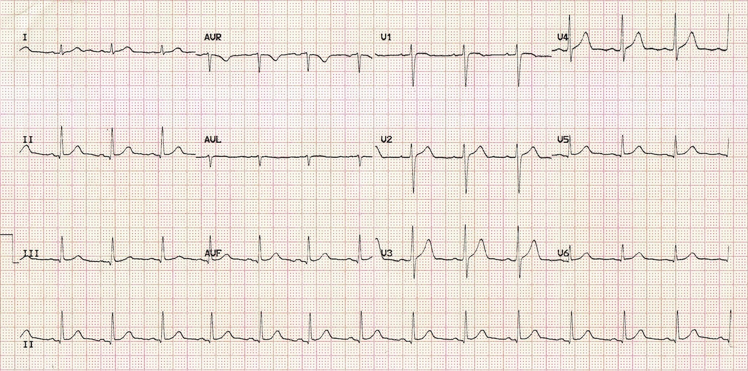  (ECG source: http://i0.wp.com/lifeinthefastlane.com/wp-content/uploads/2011/12/normal-sinus-rhythm.jpg) | Initial ECG on ward (Anterolateral TWI)  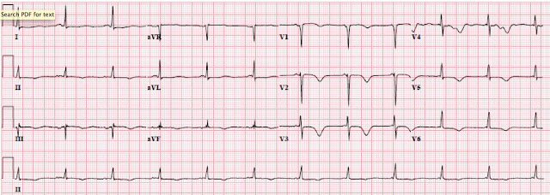  (ECG source: http://hqmeded-ecg.blogspot.ca/2015/12/lvh-with-anterior-st-elevation-when-is.html)
Repeat ECG on ward (anterolateral STEMI)  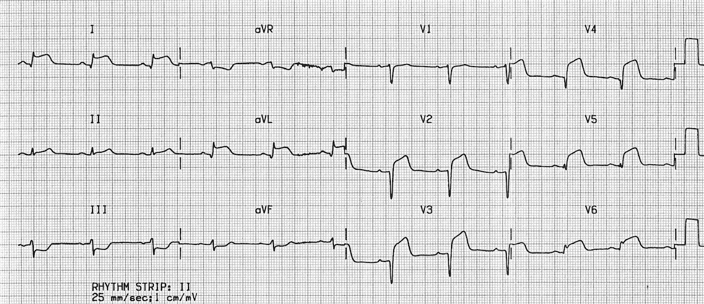  (ECG source: http://i0.wp.com/lifeinthefastlane.com/wp-content/uploads/2011/10/recent-anteroseptal.jpg) | CXR: CHF  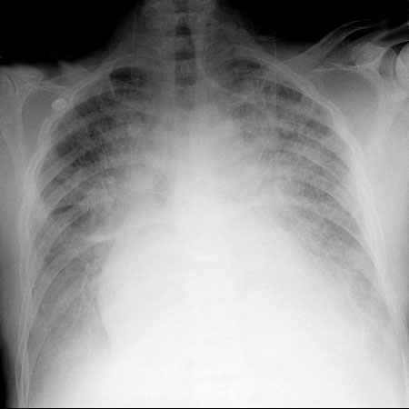  (CXR source: https://www.med-ed.virginia.edu/courses/rad/cxr/web%20images/into-chf.jpg)
Ultrasound Video Files (if applicable)
None for this case.

Section VIII: Debriefing Guide

General Debriefing Plan
Individual | Group |  | With Video | Without Video
Objectives
Educational Goal: |  | To review an approach to chest pain in the admitted patient and to review resources available to junior learners when on call overnight.
CRM Objectives: |  | Seeks input from team members and calls for help as needed.
Medical Objectives: |  | - Advises nurse of tasks to perform prior to arrival at bedside.  - Performs brief and appropriate history/physical.  - Recognizes and treats CHF and evolving chest pain.
Sample Questions for Debriefing
- What are some approaches to managing phone calls from the ward about patients you don’t know?
- What was the cause of this patient’s chest pain? How did it feel to make that diagnosis on a ward?
- What resources are available to you on the ward overnight? Who can you call if you are feeling “in over your head”?
- Who should you call if you have an admitted patient with a STEMI? An admitted patient who dies?
Key Moments
Initial instructions over the phone
Recognizing ECG changes
Calling for help

